The NWCPEA Best Practice in Physical Education Award
Open Call for 2022 Applications
Deadline Friday 27th May 2022!

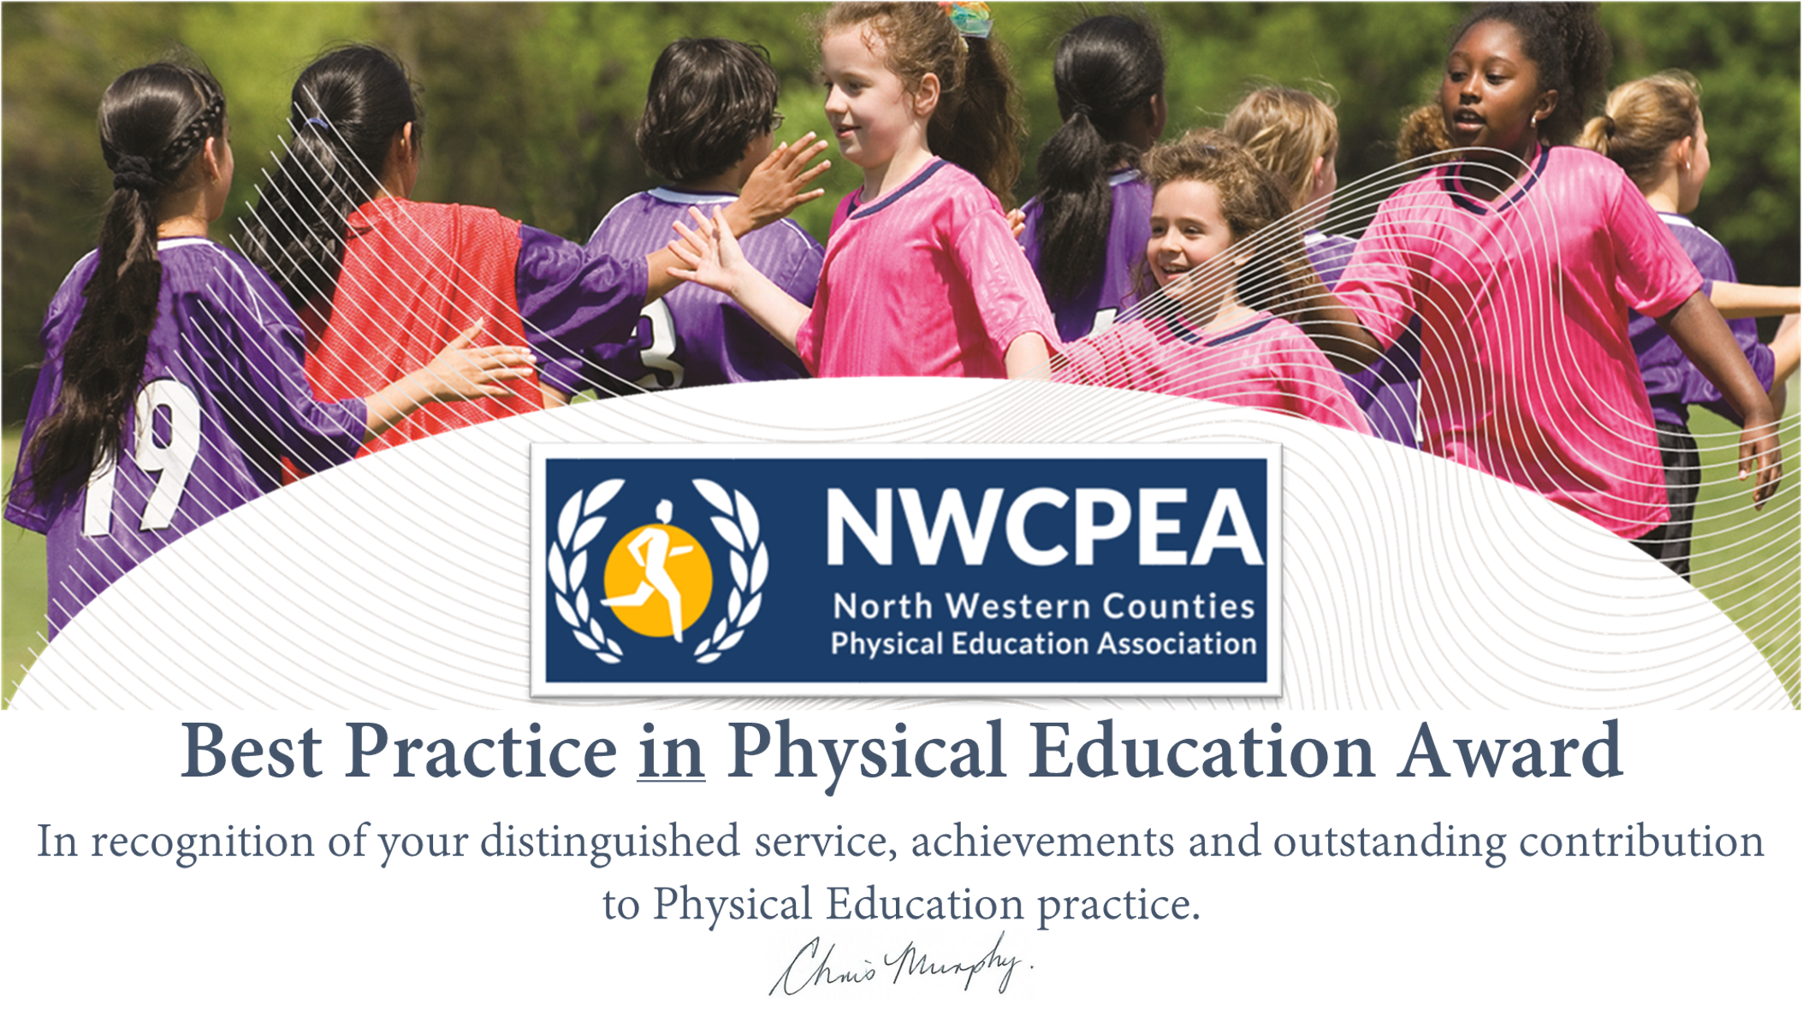

The Award is open to individuals working in Physical Education. We have three Best Practice awards available to (1) Primary School, (2) Secondary School and (3) Special School. This is open to any group of people who have worked together on a successful physical education-related project or case study. It will celebrate best practice in Physical Education settings and the evidence for the award may be related to any of the following categories:
- High Quality Physical Education – across the school
- Innovative Teaching and Learning in Physical Education (including e.g. curriculum development, negotiated teacher/pupil learning, assessment processes, cross-curricular issues and whole school links etc.)
- Inclusion and Equity
- Physical Education activities beyond the curriculum
- Physical Education links with the community
- Raising Awareness of physical education’s contribution(s) to healthy well-being/active lifestyles
- Improving life chances of ‘at risk’ students through Physical Education
- Physical Education in a Technological World (e.g. use of ICT)
- Continuing Professional Development
- Leadership or Management
- International Links
The Award comprises a Best Practice in Physical Education Certificate along with a NWCPEA ‘Best Practice’ Logo 2022.
Nominees should be:
- Physical Education/School Sport practitioners in primary, secondary or special school settings
- Other persons who have contributed significantly to developing best practice in Physical Education/School Sport in the North West Region.
- Nominations must be made on the official proforma available at www.nwcpea.org and submitted to Rita Hesford ritahesford@hotmail.com no later than Friday 28^{7h} May 2022.

We look forward to hearing about your best practice!

