Games Maker
Through the creative minds of young people in Years 3 – 6 we have many games you can take part in, created by children in Lancashire, for the young people of the North West.
Use the video demonstrations to watch and learn how to play the games, and the formats for more information on the rules.
Thank you to Ethan, Leonie, Park Community Academy, St Peter’s Roman Catholic Primary School and Isabelle and Emma for their games. Enjoy and have fun taking part!

Page 2-3
- Ethan’s Dodge Tennis Game (Wheatley Lane Primary School, Pendle) Video Demonstration
Page 4-5
- Park Community Academy Students (Blackpool) ‘Target Ball’ Game (Video Demonstration)
Page 6-7
- Isabelle and Emma’s Farmers Feud Game (Clayton Le Moors All Saints Primary School, Hyndburn) Video Demonstration
Page 8-9
- Leonie’s Flag Thief Game (Langho St Leonards Primary School, Ribble Valley) Video Demonstration

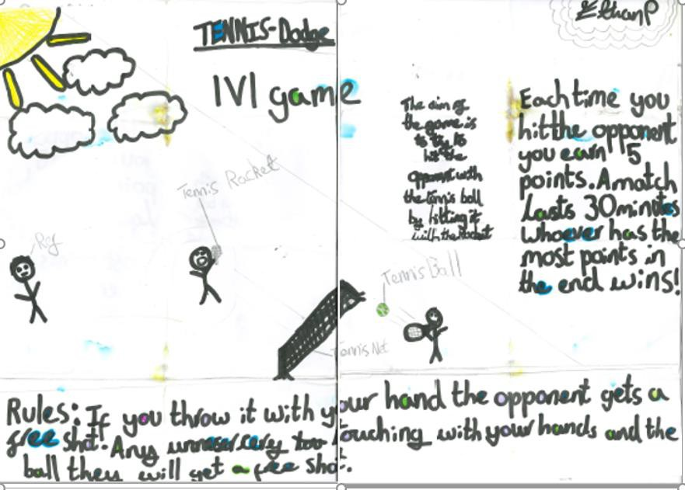
Games Maker – Ethan’s Dodge Tennis

Are you ready to try Ethan from Wheatley Lane Primary School (Pendle) game? Have fun, adapt to suit your equipment, space and ability of participants.

Ethan’s Dodge Tennis

Video Demonstration (Click Here)

You will need:
• Tennis Racket & Soft ball/sponge ball
• Alternative Hand & Rolled Up socks
• A referee/willing participants
Much like Dodgeball the aim of the game is to hit your opponent with the ball/rolled up socks. Ethan’s game indicates that there is a time limit and can be played 1 v 1. You could also be creative and try and play in teams, make the games shorter.
You can play & count up points (5 each time an opponent is hit) or play it like dodgeball and when the player is hit, they sit out until the game is completed. Try different versions!
Share your videos and photos.
We want to see you trying this learn exercise at home, please share your videos and photos - Twitter- @NWCPEA

Games Maker – Park Community Academy ‘Target Ball’
Are you ready to try Park Community Academy (Blackpool) game? Have fun, adapt to suit your equipment, space and ability of participants.

Park Community Academy’s Target Ball Games

Video Demonstration (Click here)
You will need:
- 5 tennis balls/bean bags/rolled up socks
- Cones/Makers to mark the target zone.
- Different coloured cones/markers for the 10-point zone, 2 defensive zones, 5-point zone x 2 (1 at each end of the court).
How to Play
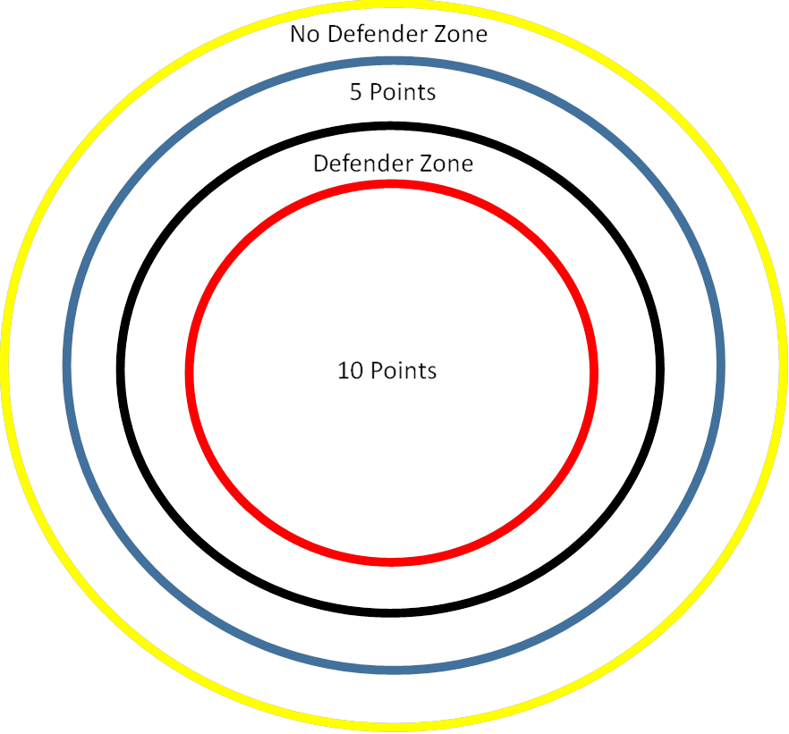
It is a two teamed game with minimum of 7-a-side. 5 Outfield players who can pass/move 3
steps to get the ball to the target area to ty and achieve points +1
defender, 1 attacker (catcher)
The aim is to get the balls in to a player in the target zone. The attacker can tell the player in the target zone whether they want them in the 5-point zone which is unopposed or the 10- point zone which is opposed.
If a ball is dropped at any point it goes to the opposition. Each half last for 10 minutes but can be
increased or reduced and can only be one half if needed.

The game is played on an area the size of a tennis court. The ball must be caught for the points to count.
How to start the Game
Line up 5 balls in the middle of court/playground and have both teams run to collect, much like the start of Dodgeball game. Naturally, 1 team will have more balls to start with than the opposition.
Teams then pass and move (no more than a few steps) to work their way towards their target zone (Very similar to Netball). Your aim being trying to pass the ball to the attacker with the opposition defender trying to stop you.
This is a great game for all, but especially SEND pupils and special schools as it will develop many skills, including work as a team, catching and movement.

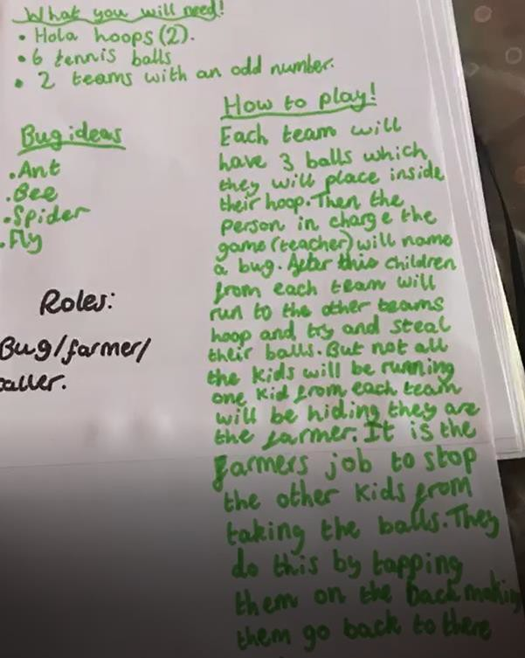

Games Maker – Isabelle & Emma’s Farmers Feud Game
Are you ready to try Isabelle and Emma’s game? Have fun, adapt to suit your equipment, space and ability of participants. Isabelle and Emma are from Clayton Le Moors All Saints Primary School, Year 6 – Hyndburn

Isabelle and Emma’s Farmers Feud Game

Video Demonstration (Click here)
You will need:
- 2 Hula Hoops (Use alternatives such as cones to if no hoops)
- 6 tennis balls
- 2 Teams (Each team has 1 farmer).
How to Play
Each Team will have 3 balls in their hoop on their side of the playground, court, hall etc.
The game will start with each team in their hoop/or near to their hoop.
The teacher will then call a bug name (be creative) and the teams will run towards the other team’s hula hoop to try and steal their balls. However, one team player from each side will be the farmer. Their role is to tag the opposition players on the back when a bug name is called, meaning the players cannot steal the opposition balls and are out of that particular game if tagged.
The aim of the game is to have the most tennis balls in your hoop by the time the teacher shouts, STOP!

Players can only take one ball at a time, and when tagged by the farmer, must sit out until a new bug name is called.
If tagged when in possession of a ball, then ball must go back to its original hoop.
Be Creative and adapt Farmer Feud to your pupils needs!
You could encourage teams to pass and throw the ball to their hoop, once someone has retrieved a ball to practice and develop their catching, teamwork and communication skills.

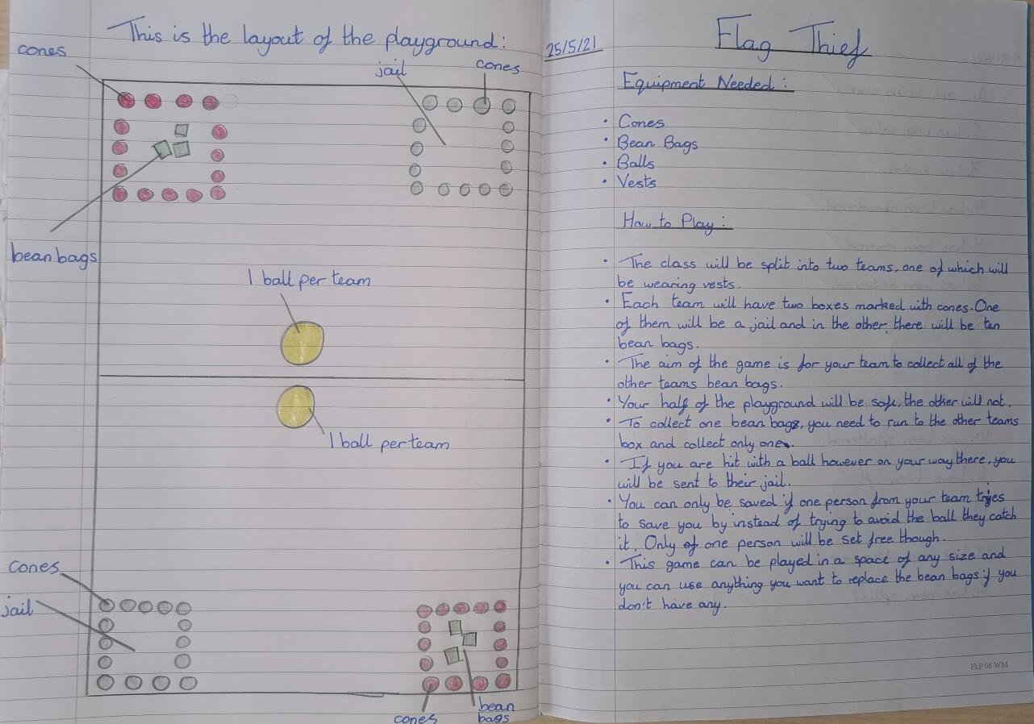
Games Maker – Leonie’s Flag Thief Games
Are you ready to try Leonie game? Have fun, adapt to suit your equipment, space and ability of participants. Leonie is from Langho St Leonards (Year 6), Ribble Valley.
Leonie’s Flag Thief Game Video Demonstration (Click Here) You will need:
- Cones/markers
- 2 Balls (1 per team)
- Bean Bags/rolled up socks
- Vests/Bibs or a way to separate and identify two teams

The class will be split into two different teams. Each team on their side of court will have a jail and a space where their 10 bean bags are kept.
The aim of the game is to get all of the other team’s bean bags, by going to collect them from the other side. However, with this comes risk. With your 1 ball, much like dodgeball the opposition will be trying to hit you, to put you in their jail. If you are hit you must go into their jail and only be released if another player goes to the other side and manages to catch the ball from the opposition when they are trying to put them in jail by hitting them with the ball.
The aim is to collect all the other teams bean bags and become the winning team

