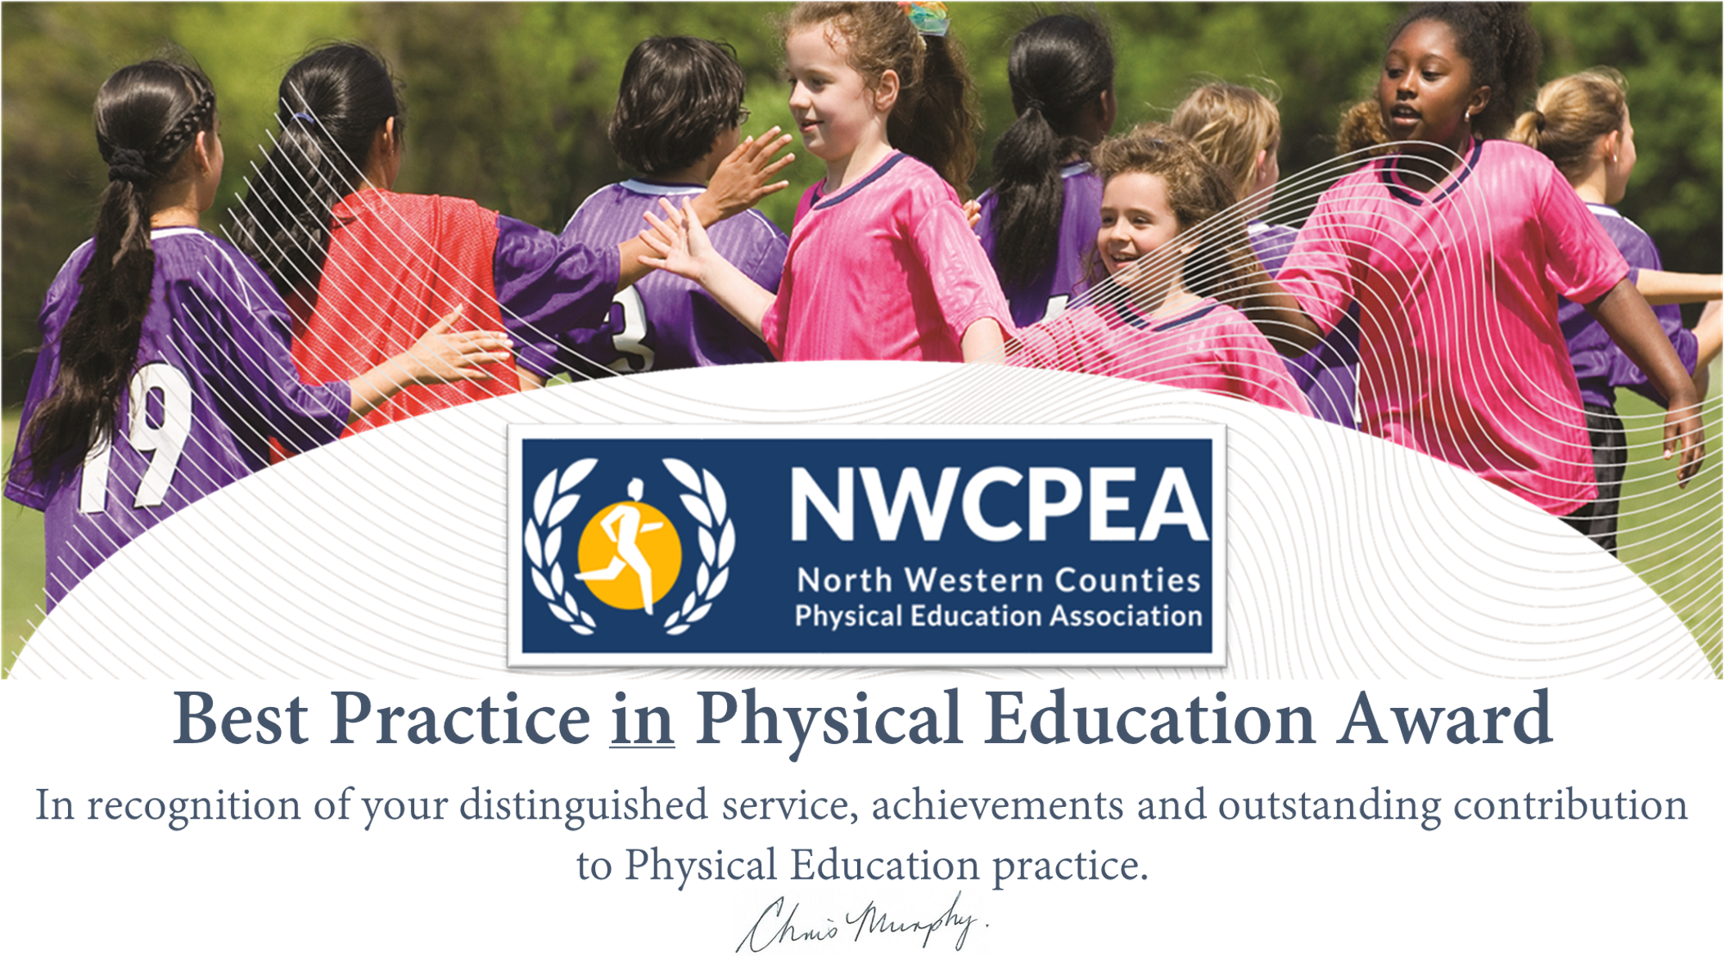

Best Practice in Physical Education Award 2020
Nomination Pro-forma

Name of Nominee
Position
Contact Details
-e mail address
Nominated By:
Position
Contact Details
-e mail address
Seconded by:
Position
Contact Details
-e mail adress
Basis for Nomination/Details of Best Practice to include Impact on Pupils/School
(300-500 words)
North Western Counties Physical Education Association
Please send all applications to Rita Hesford by Friday 29th May, 2020

Address:
20 Brookdale Avenue
Marple
Cheshire, SK67HP
United Kingdom

Email: ritahesford@hotmail.com

www.nwcpea.org/

