Best Practice in Physical Education Innovation Award 2019
Nomination Pro-forma
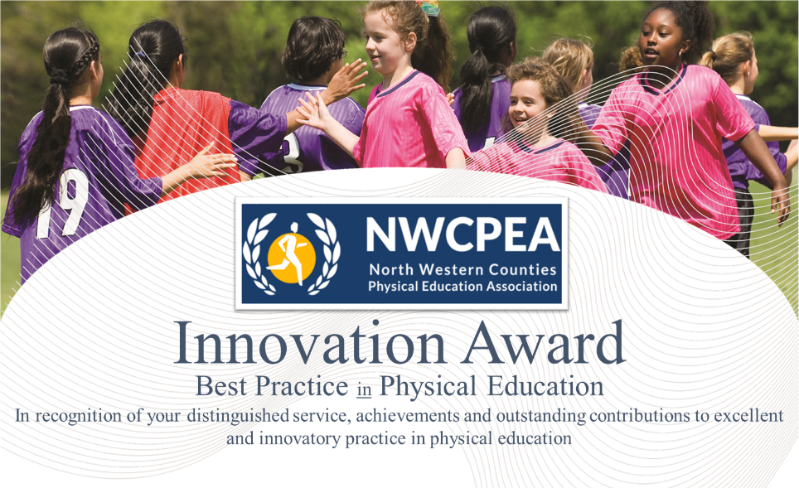

Name of Nominee
Position
Contact Details
-e mail address
Nominated By:
Position
Contact Details
-e mail adress
Seconded by:
Position
Contact Details
-e mail adress
Basis for Nomination/Details of Best Practice to include Impact on Pupils/School
(300-500 words)
North Western Counties Physical Education Association
Please send all applications to Rita Hesford by Friday 17th May, 2019

Address:
20 Brookdale Avenue
Marple
Cheshire, SK67HP
United Kingdom

Email: ritahesford@hotmail.com

www.nwcpea.org/

