The NWCPEA Innovation Award
Open Call for 2018 Applications
Deadline Friday 11th May 2018!
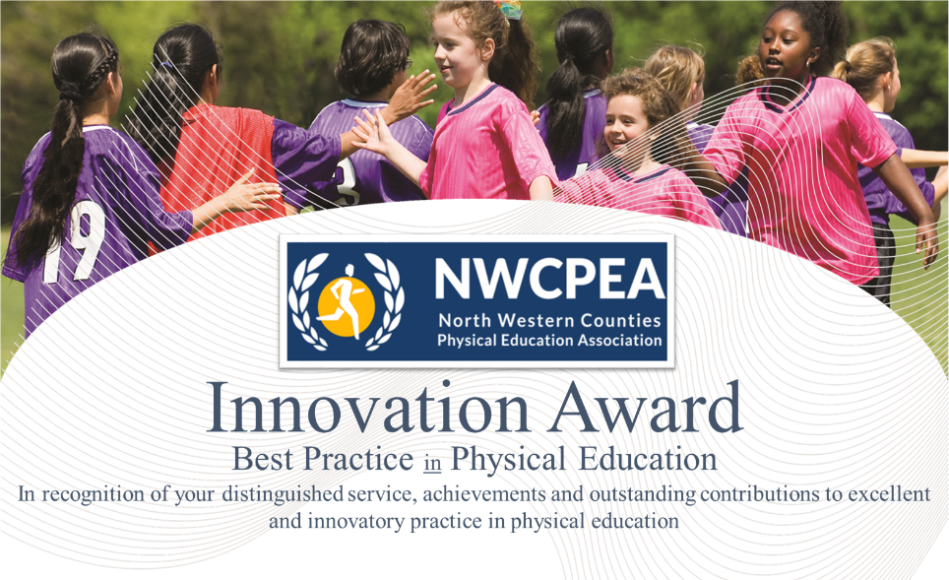
The Award is open to individuals working in Physical Education, either in Primary and/or Secondary school, or to a group of people who have worked together on a successful physical education-related project or case study. It will celebrate innovatory practice in Physical Education settings. The evidence for the award may be related to any of the following categories:
- High Quality Physical Education – across the school
- Innovative Teaching and Learning in Physical Education (including e.g. curriculum development, negotiated teacher/pupil learning, assessment processes, cross-curricular issues and whole school links etc.)
- Inclusion and Equity
- Physical Education activities beyond the curriculum
- Physical Education links with the community
- Raising Awareness of physical education’s contribution(s) to healthy well-being/active lifestyles
- Improving life chances of ‘at risk’ students through Physical Education
- Physical Education in a Technological World (e.g. use of ICT)
- Continuing Professional Development
- Leadership or Management
- International Links
The Award comprises a cheque for £250 and a Best Practice in Physical Education Innovation certificate.
Nominees should be:
- Physical Education/School Sport practitioners in primary or secondary school settings
- Other persons who have contributed significantly to good and/or innovatory practice in Physical Education/School Sport in the North West Region.
- Nominations must be made on the official proforma available at www.nwcpea.org and submitted to Rita Hesford ritahesford@hotmail.com no later than Friday 11th May 2018.

We look forward to hearing about your innovative practice!

